

Practices for Secure Software Report

Table of Contents
Document Revision History 3
Client 3
Instructions 3
Developer 4
1. Algorithm Cipher 4
2. Certificate Generation 4
3. Deploy Cipher 4
4. Secure Communications 4
5. Secondary Testing 4
6. Functional Testing 4
7. Summary 4
8. Industry Standard Best Practices 4

Document Revision History

Version | Date | Author | Comments
1.0 | 2/22/2026 | Andrew Fisher

Client



Instructions

Submit this completed practices for secure software report. Replace the bracketed text with the relevant information. You must document your process for writing secure communications and refactoring code that complies with software security testing protocols.

- Respond to the steps outlined below and include your findings.
- Respond using your own words. You may also choose to include images or supporting materials. If you include them, make certain to insert them in all the relevant locations in the document.
- Refer to the Project Two Guidelines and Rubric for more detailed instructions about each section of the template.

Developer
Andrew Fisher

Algorithm Cipher

Artemis Financial needs to protect long-term archive files that likely contain sensitive customer and financial data. Because these records may be stored for many years, the main concern is ensuring that the data remains confidential and unchanged over time. Since Artemis Financial develops individualized financial plans that include retirement accounts, savings, and investments, a breach could expose highly sensitive personal and financial information. The encryption method must therefore be strong enough to resist modern attacks, while still being practical to implement within a Java-based system.
AES-256 is an appropriate cipher for this scenario because it balances strength and efficiency. AES is a symmetric algorithm, meaning the same key is used for encryption and decryption. For archived financial records, this makes sense because the company primarily needs to protect stored data rather than exchange it between unknown parties. Symmetric encryption performs well even when handling large archive files, which makes it practical for this situation. The 256-bit key size significantly increases resistance to brute force attacks, making it highly unrealistic that an attacker could successfully guess the key, especially for data intended to remain secure for many years.
While encryption protects confidentiality, it does not automatically guarantee integrity. That is where hash functions become important. In this project, SHA-256 was implemented to generate a checksum for a unique data string. A hash function produces a fixed length output that changes completely if even a small part of the input changes. This property makes it useful for verifying that data has not been altered. SHA-256 produces a 256-bit output, which provides strong collision resistance compared to older algorithms such as MD5. Demonstrating checksum verification in the application shows how integrity checks work in practice, not just in theory.
It is also important to understand the difference between symmetric and asymmetric encryption. AES is symmetric and works best for encrypting stored data efficiently. Asymmetric algorithms such as RSA use separate public and private keys and are commonly used for secure key exchange and digital certificates. In real-world systems, asymmetric encryption often protects the transmission of symmetric keys, which are then used to encrypt larger amounts of data. Recognizing when to use each approach is part of designing a secure system rather than simply choosing the strongest algorithm available.
Another critical component is secure key generation. Even a strong algorithm can be weakened if keys are predictable or poorly managed. Keys must be generated using secure random values and stored separately from the encrypted data. Proper key management policies are just as important as selecting the algorithm itself, because losing control of the key would make the encryption ineffective.
Encryption standards have evolved over time as computing power has increased. Algorithms that were once considered secure are now outdated because they can be broken more quickly. AES replaced many older methods and remains widely trusted in financial and enterprise environments. Its continued support within Java’s security libraries makes it a practical and stable choice for Artemis Financial.
In this project, these concepts were applied in a working Java application. SHA-256 hashing was implemented to demonstrate data integrity through checksum verification, and HTTPS was configured to secure communication using TLS. Since Artemis Financial operates a public web interface, securing data being transmitted between the client and server is especially important to prevent interception. Together, these steps demonstrate how encryption and hashing work at different layers of security, protecting both stored data and data being sent.

Certificate Generation
Insert a screenshot below of the CER file.

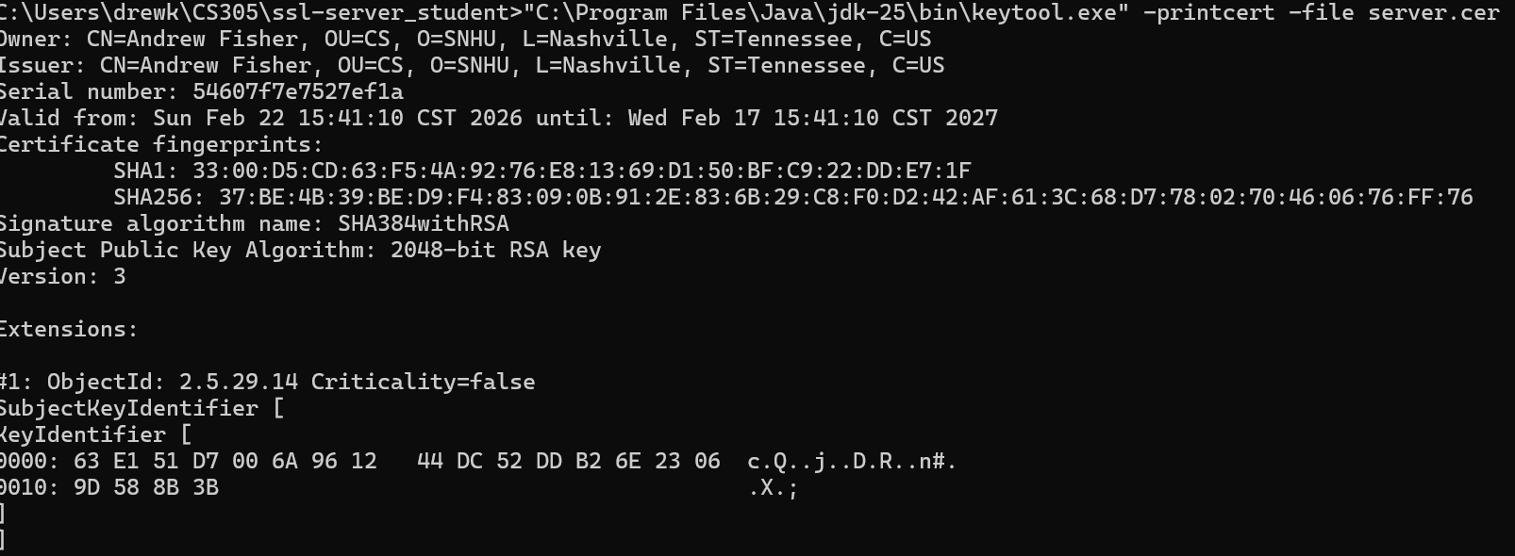

Deploy Cipher
Insert a screenshot below of the checksum verification.

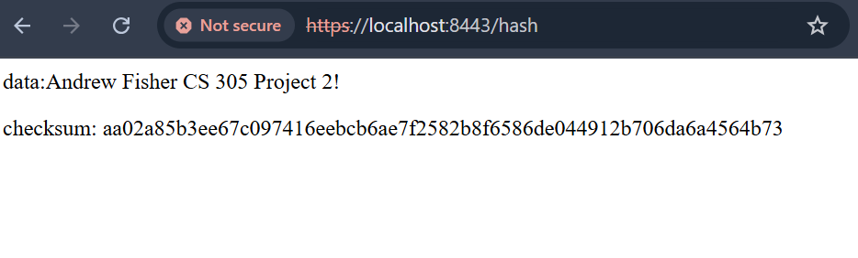

Secure Communications
Insert a screenshot below of the web browser that shows a secure webpage.



Secondary Testing
Insert screenshots below of the refactored code executed without errors and the dependency-check report.

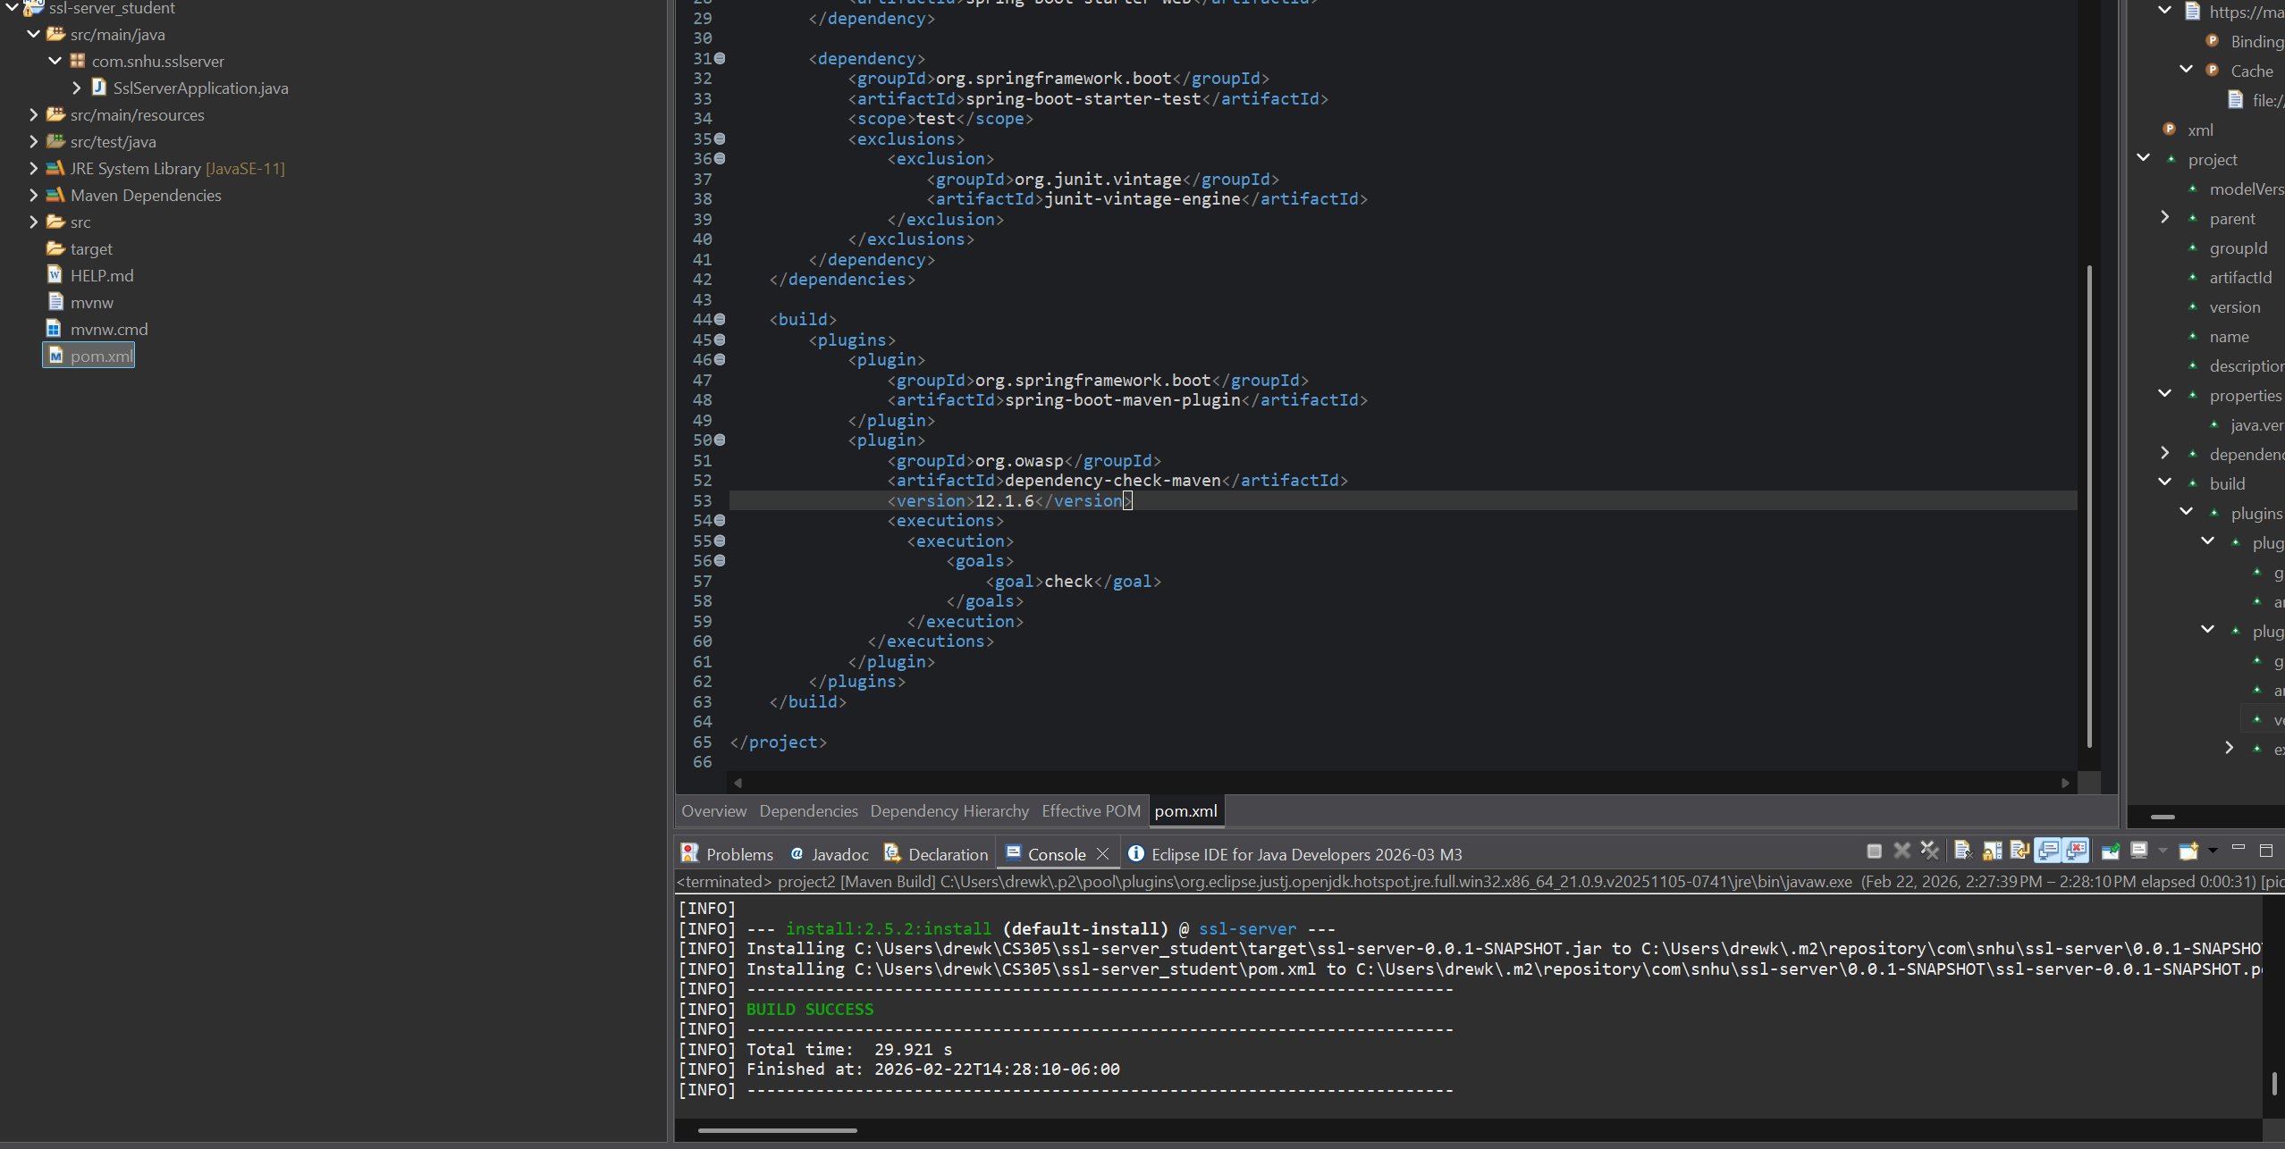
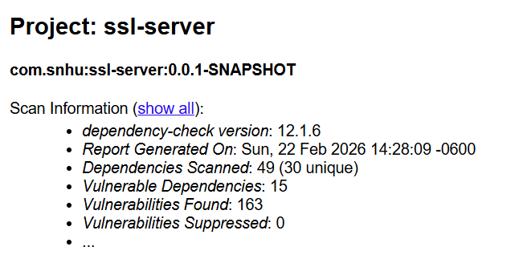

Functional Testing
Insert a screenshot below of the refactored code executed without errors.
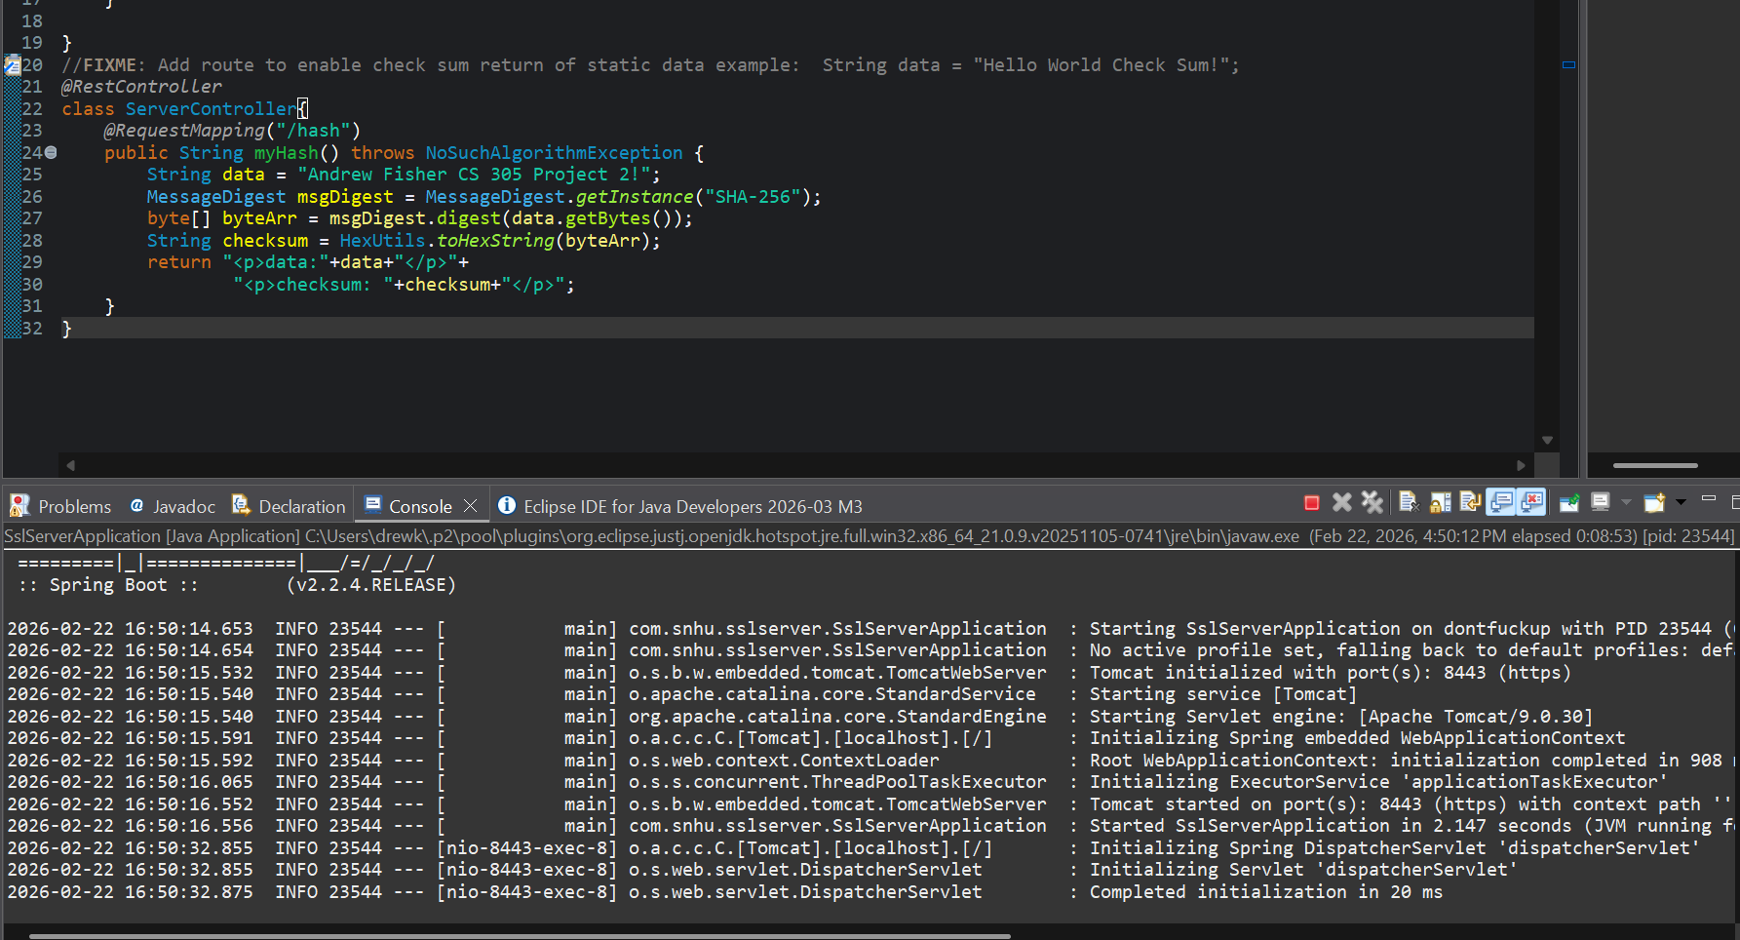

Summary

During this project, I followed the vulnerability assessment process shown in the diagram and applied it to the changes I made in the application. I started with the architecture review stage by updating the dependency versions in the pom.xml file and running the OWASP dependency-check tool. This helped me see any existing vulnerabilities in the project before adding new functionality. Running the scan first gave me a better understanding of the application’s overall security state.
Next, I focused on the cryptography portion of the process. I refactored the SslServerApplication.java file to implement SHA-256 hashing for checksum verification. This added an integrity check so the application can confirm that data has not been modified. Seeing the checksum output match for identical input helped me understand how hashing protects against unnoticed changes to data.
I also addressed the client/server portion of the diagram. After generating a self-signed certificate, I updated the application.properties file to enable HTTPS on port 8443. This ensured that communication between the client and server is encrypted instead of being sent in plain text. Since Artemis Financial uses a public web interface, encrypting transmitted data is especially important to protect client information.
After completing these changes, I compiled and ran the application to make sure it executed without errors. I manually reviewed the updated files and ran a secondary dependency-check scan to confirm that no additional vulnerabilities were introduced during refactoring. This step helped reinforce the importance of testing after making security changes rather than assuming they are correct.
Overall, this project showed me how security improvements should be layered. I first reviewed the architecture, then added cryptographic protection, secured communication, and verified everything through testing and scanning. Following the structured process in the diagram made the refactoring feel more intentional and helped me better understand how secure development practices are applied in real applications.

Industry Standard Best Practices

Throughout this project, I applied several industry-standard secure coding practices while refactoring the application. One of the first steps I took was running the OWASP dependency-check tool after reviewing and updating the pom.xml file. In industry settings, regularly scanning dependencies for known vulnerabilities is a standard practice because many security issues come from third-party libraries rather than original code. Starting with a dependency review helped ensure I was building on a secure foundation.
When implementing checksum verification, I followed the best practice of using established cryptographic algorithms instead of attempting to create a custom solution. SHA-256 is a widely trusted hashing algorithm, and using it supports the principle of relying on proven standards rather than developing insecure alternatives. Similarly, enabling HTTPS through TLS follows industry expectations for securing communication in public-facing web applications. Encrypting data being transmitted between the client and server protects against interception and aligns with common security requirements.
I also applied a layered security approach. Instead of making only one change, the application now includes dependency scanning, hashing for integrity verification, and encrypted communication. This reflects how secure systems are typically designed in practice, where multiple safeguards work together rather than relying on a single control.
Another important best practice was testing after each major change. After refactoring the code, I compiled and executed the application to confirm it ran without errors. I then performed a secondary dependency-check scan and manually reviewed the updated files. Re-testing after changes is an important part of secure development because it verifies that improvements do not introduce new vulnerabilities.
Applying these best practices helps maintain the application’s existing security while strengthening it. For Artemis Financial, which handles sensitive financial data through a public web interface, following secure development standards supports client trust and reduces overall risk. This project reinforced how industry standards are not just guidelines, but practical steps that improve both security and reliability

